Forecasting Pound value using Macro Economic Indicators

**Abstract:**

The global economy has been changing significantly over the past few centuries, in the way it is being organized, governed and controlled by developed and developing nations and a main macro-economic factor that gives the nations to govern the global economy id the value of the state currency. Predicting the currency value provide a great opportunity for investors to make investment and other countries to make trade deals. Over past few years computational intelligence-based methods for predicting macroeconomic variables like currency values have been proven highly successful and accurate. We have implemented various multivariate time series approach to forecast the Pound value and parallelly compared the performance of three multivariate prediction models:

**Introduction:**

Macro-economic indicator and influencers forecasting has been a challenging application since the beginning of computational intelligence as it deals with multi-variant financial and macro-economic time series. In this project we have implemented and highlight the efficacy of multivariate time series forecasting, these models rely on greater information, lagged time series and few other indicators like technical, fundamental, inter-market are forecasted. We a have implemented three multi-variant models, they are Vector Auto-Regressive(VAR) model , Support Vector Machine and Long Short-Term Memory based Recurrent Neural Network.

**DATA:**

We have used quarterly and monthly historical data from 1971 to December 2022 for the United Kingdom to develop different models that can estimate Pound value. We have collected data from multiple sources according to the forecast model requirement and accessibility of data.

**Source:**

* <https://www.bankofengland.co.uk/>.
* **GDP :**
  + <https://www.theguardian.com/news/datablog/2009/nov/25/gdp-uk-1948-growth-economy>
  + From : 1961 -2021 (Quarterly)
* **Interest  Rate :**
  + <https://data.oecd.org/interest/long-term-interest-rates.htm>
  + From : 1953 - Present (Monthly)
* **Inflation Rates:**
  + <https://www.rateinflation.com/inflation-rate/uk-historical-inflation-rate/>
  + https://www.ons.gov.uk/economy/inflationandpriceindices/timeseries/czbh/mm23
  + From : 1989 - Present ( Monthly)
* **Employment Rate :**
* <https://data.oecd.org/emp/employment-rate.htm>
* From : 1955 - Present ( Quarterly)
* **Unemployment Rate:**
* <https://data.oecd.org/unemp/unemployment-rate.htm>
* https://www.ons.gov.uk/employmentandlabourmarket/peoplenotinwork/unemployment/timeseries/mgsx/lms
* From : 1953 - Present ( Monthly)
* **Government Debt to GDP** :
* <https://ourworldindata.org/grapher/uk-government-debt-as-a-percentage-of-gdp-17272016>
* From: 1727 -2020 (Yearly)
* **Industrial Production:**
  + <https://data.oecd.org/industry/industrial-production.htm>
  + From : 1956 - 2022 (Monthly)
* **Treasury bill Discount:**
* <https://fred.stlouisfed.org/series/TBDRUKM>
* Till 2017 (Daily data)
* <https://www.ons.gov.uk/economy/governmentpublicsectorandtaxes/publicsectorfinance/timeseries/bkpj/pusf>
* From 1993 to 2022
* **Crude Oil Production:**
* <https://data.oecd.org/energy/crude-oil-production.htm>
* From : 1960-2017 (Yearly)
* **Crude Oil Import Prices:**
* <https://data.oecd.org/energy/crude-oil-import-prices.htm>
* From : 1980- 2021 (Yearly)
* **Gold Prices:**
* <https://nma.org/wp-content/uploads/2016/09/historic_gold_prices_1833_pres.pdf>
* From : 1850 - 2016 (Yearly)
* **LIBOR :**
* <https://sdw.ecb.europa.eu/quickview.do?SERIES_KEY=143.FM.M.GB.GBP.RT.MM.GBP3MFSR_.HSTA>
* From: 1986 to 2022 (monthly)

**Feature Engineering:**

The **Granger causality test** is a statistical hypothesis test for determining whether one time series is useful for forecasting another.

**Augmented Dickey–Fuller test** – In statistics and econometrics, an augmented Dickey–Fuller test, tests the null hypothesis that a unit root is present in a time series sample.

As the Granger causality test has shown that every time series causes the pound time series in some or the other way, we have taken 1 month , 2 month lag and a 6 month moving average mean of each and every column. WE got a total of 34 columns as features.

**Data Visualization:**

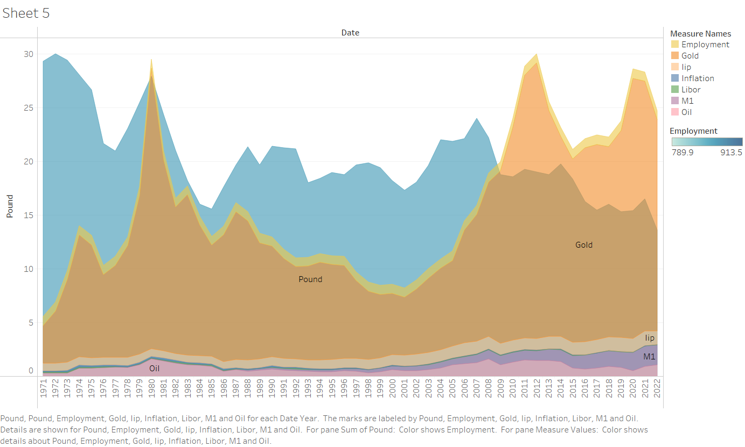

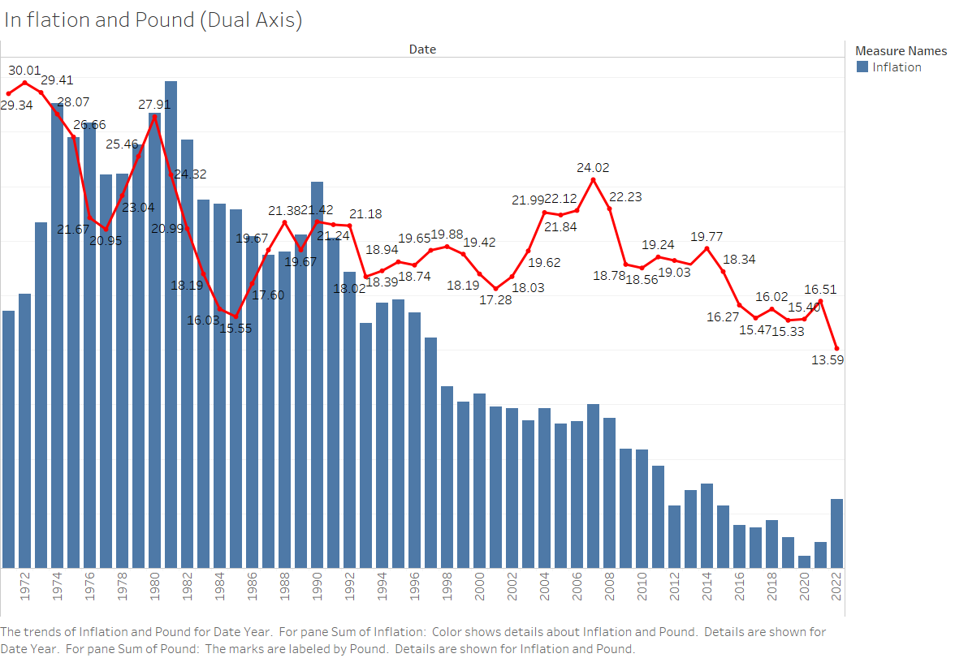

**Methodology:**

Since the features extracted from the dataset displays the characteristics of collinearity and causality. We are using 3 models which are suitable for this time series data for interpreting the pound value.

**Vector autoregression (VAR):**

* It is a multivariant time series forecasting algorithm that is used when two or more time series influence each other.
* The time series is modelled as a linear combination of its own lag(past values).
* We assume that each variable modelled as linear combination of past values of itself past values of other variables.

**Support Vector Machine (SVM):**

* Support vector machine algorithm is to find a hyperplane in an N-dimensional space(N — the number of features) that distinctly classifies the data points.
* Support vector regression from regularization parameter and Epsilon value



**Long Short-Term Memory (LSTM):**

* Artificial Neural Networks (ANNs) are being widely used to map nonlinear relationships between macroeconomic time series.
* Long Short-Term Memory (LSTM) is a special kind of RNN, capable of learning long-term dependencies by remembering information for long periods and automatically determine the optimal time lags.
* It can capture the nonlinearity and randomness of time series data more effectively, as well as overcome the problem of back-propagated error decay

Model architecture:

* Consists of input layer + LSTM RNN + dense layer
* Input layers consist of 34 variables.
* LSTM have same number of neurons whose output Is densely connected to a single output neuron.

**Image 1**

**Image 2**

**Evaluation and comparison:**

We have implemented and calculated the following parameters for the models to compare the performance of all three models:

* Mean Percentage Error: It is a relative measure that essentially scales ME to be in percentage units instead of the variable's units.
* Mean absolute percentage error: It is a measure of prediction accuracy of a forecasting method in statistics.
* Root mean squared error: It is a frequently used measure of the differences between values (sample or population values) predicted by a model and the values observed.

**Image 3**

|  |  |  |  |
| --- | --- | --- | --- |
| **Performance Metric** | **VAR Model** | **SVM Model** | **LSTM RNN Model** |
| MAPE | 0.0369 | 0.0283 | 0.0217 |
| MPE | 0.0286 | 0.0261 | 0.0031 |
| RMSE | 0.197 | 0.278 | 0.3002 |

**Table 1**

**CONCLUSIONS:**

As we can see from the above table VAR model has the least RSME and can be concluded as best fit model for the data and from the image 1 as the losses were decreasing gradually we have stopped the training of the model and developed into validation data.

This way we can forecast the pound value for a month given above attributes.